Save the Date!
May 21-23, 2019

Annual Robert W. Jackson Senior Conference
Cedar Lakes Conference Center
Ripley, West Virginia
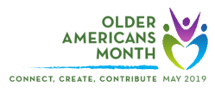

Every May, the Administration for Community Living leads our nation’s observance of Older Americans Month. We are pleased to announce the 2019 theme, Connect, Create, Contribute, which encourages older adults and their communities to:
- Connect with friends, family, and services that support participation.
- Create by engaging in activities that promote learning, health, and personal enrichment.
- Contribute time, talent, and life experience to benefit others.
Communities that encourage the contributions of older adults are stronger! By engaging and supporting all community members, we recognize that older adults play a key role in the vitality of our neighborhoods, networks, and lives.
Everyone benefits when everyone can participate. We encourage you to connect, create, and contribute for stronger and more diverse communities this May, and throughout the year.

